Deploy Insurance App to Kubernetes

Course Name: DevOps

Institution Name: Medicaps University – Datagami Skill Based Course

Student Name(s) & Enrolment Number(s):

Sr no | Student Name | Enrolment Number
01 | ANANYA MADANALA | EN22CS301119
02 | ANIND BILTHARIYA | EN22CS301129
03 | ARPITA SOLANKI | EN22CS301202
04 | ASHUTOSH SINGH | EN22CS301221
05 | AVANI SHARMA | EN22CS301240

Group Name:08D2
Project Number:DO-20
Industry Mentor Name: Vaibhav
University Mentor Name: Prof. Akshay Saxena
Academic Year: 2025-2026

TABLE OF CONTENTS
S.NO. | TOPICS
1 | INTRODUCTION | 1.1 SCOPE OF THE DOCUMENT
 |  | 1.2 INTENDED AUDIENCE
 |  | 1.3 SYSTEM OVERVIEW
2 | SYSTEM DESIGN | 2.1 APPLICATION DESIGN
 |  | 2.2 PROCESS FLOW
 |  | 2.3 INFORMATION FLOW
 |  | 2.4 COMPONENTS DESIGN
 |  | 2.5 KEY DESIGN CONSIDERATIONS
 |  | 2.6 API CATALOGUE
3. | DATA DESIGN | 3.1 DATA MODEL
 |  | 3.2 DATA ACCESS MECHANISM
 |  | 3.3 DATA RETENTION POLICIES
 |  | 3.4 DATA MIGRATION
4. | INTERFACES
5. | STATE AND SESSION MANAGEMENT
6. | CACHING
7. | FUNCTIONAL REQUIREMENTS | 7.1 CONTAINERIZATION AND IMAGE BUILD
 |  | 7.2 KUBERNETES DEPLOYMENT
 |  | 7.3 ROLLING UPDATES (ZERO DOWNTIME)
 |  | 7.4 MONITORING AND LOGGING
8. | NON-FUNCTIONAL REQUIREMENTS | 8.1 SECURITY
 |  | 8.2 PERFORMANCE
 |  | 8.3 SCALABILITY
 |  | 8.4 RELIABILITY
9. | REFERENCES

1. INTRODUCTION
The rapid evolution of cloud-native technologies has made container orchestration a fundamental pillar of modern software deployment. DevOps practices, particularly the use of containerization and orchestration platforms, enable teams to deliver reliable and scalable applications with minimal manual effort. This project focuses on deploying an Insurance Application onto a Kubernetes cluster (Minikube) using Docker for containerization, Git for version control, and Jenkins/GitHub Actions for CI/CD automation.
The Insurance Application is containerized using Docker, packaged into a Docker image, and deployed onto Kubernetes as a managed workload. A key aspect of this system is the implementation of zero-downtime 'Rolling Updates', which ensures seamless transitions between application versions without any service interruption for end-users. Kubernetes manages the lifecycle of application pods, handles load balancing, and ensures high availability through automated self-healing mechanisms.
This High-Level Design (HLD) document outlines the overall architecture, workflow, and design principles of the system, providing a comprehensive understanding of how each component contributes to a resilient and production-ready deployment pipeline.

1.1 SCOPE OF THE DOCUMENT
This document presents the High-Level Design (HLD) for the 'Deploy Insurance App to Kubernetes' project. It defines the overall system architecture and describes how tools such as Git, Docker, Jenkins/GitHub Actions, and Kubernetes (Minikube) are integrated to orchestrate containerized application deployments. The document provides a clear understanding of system structure, process flow, and deployment strategy, specifically focusing on Rolling Updates to achieve zero-downtime deployments, without delving into low-level implementation details.

1.2 INTENDED AUDIENCE
- Project Evaluators use this document to assess system design, architecture, and feasibility.
- DevOps Engineers use it to understand the Kubernetes deployment workflow and CI/CD automation.
- Developers refer to it to understand how application code integrates with the pipeline.
- System Administrators use it to manage Kubernetes cluster infrastructure and monitor deployments.
- Students and Beginners in DevOps use it to learn Docker and Kubernetes deployment concepts.

1.3 SYSTEM OVERVIEW
The system automates the complete containerized deployment lifecycle of the Insurance Application. A developer pushes code changes to a GitHub repository, which triggers the CI/CD pipeline (Jenkins or GitHub Actions). The pipeline builds and packages the application into a Docker image, which is pushed to Docker Hub. Kubernetes (Minikube) then pulls this image and deploys it as managed pods. Rolling Updates are configured to update the application across pods incrementally, ensuring continuous service availability. The system ensures high availability, scalability, and fault tolerance through Kubernetes' built-in orchestration capabilities.

2. SYSTEM DESIGN
The system design of the Kubernetes deployment for the Insurance Application follows a modular, container-first architecture that integrates multiple DevOps tools to ensure efficient, reliable, and scalable software delivery. The application is packaged as a Docker container, managed by Kubernetes manifests (Deployment and Service YAML files), and deployed onto a Minikube cluster. The CI/CD pipeline handles automated image building and delivery, while Kubernetes handles orchestration and zero-downtime rolling updates.

2.1 APPLICATION DESIGN
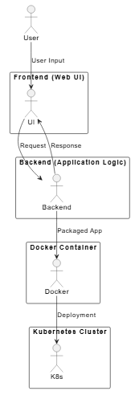

2.2 PROCESS FLOW
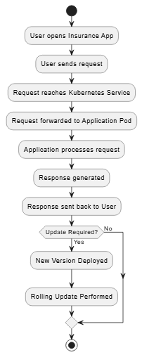
2.3 INFORMATION FLOW
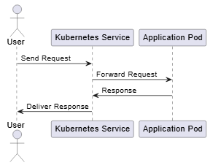

2.4 COMPONENTS DESIGN
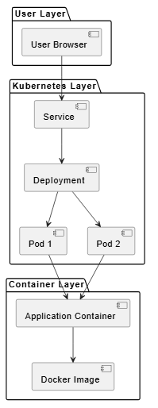
2.5 KEY DESIGN CONSIDERATIONS
- High Availability: Multiple replicas (pods) of the application run simultaneously so the app remains accessible even if individual pods fail.
- Zero Downtime Deployment: Rolling Updates progressively replace old pods with new ones, ensuring users experience no service interruption during updates.
- Scalability: The number of application pod replicas can be scaled up or down easily using Kubernetes scaling commands or HPA.
- Reliability: Kubernetes automatically restarts crashed pods via its self-healing mechanism ensuring continuous application availability.
- Portability: Docker containers ensure the application runs consistently across development, testing, and production environments.
- Automation: The CI/CD pipeline minimizes manual intervention, reducing human error in the build, push, and deployment process.
- Efficient Resource Usage: CPU and memory limits are defined in deployment manifests to prevent resource over-consumption on the cluster.

3. DATA DESIGN
The data design for this Kubernetes-based deployment system focuses on managing configuration data, container image metadata, deployment state, and operational logs across the entire software delivery lifecycle. The system maintains structured records related to source code, Docker images, Kubernetes manifests, and cluster state information to ensure traceability, rollback capability, and effective system monitoring.

3.1 DATA MODEL
- The system includes entities such as Repository, Docker Image, Kubernetes Deployment Object, Kubernetes Pod, and Kubernetes Service Object.
- These entities represent different stages of the containerized deployment pipeline from code to running application.

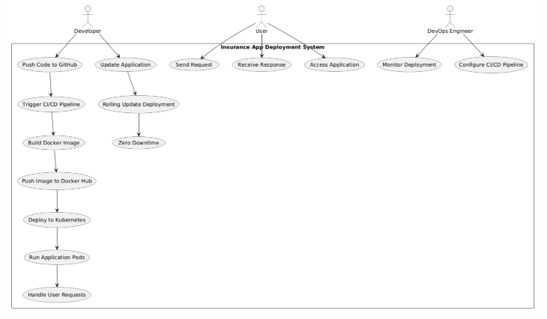

HLD Design Model
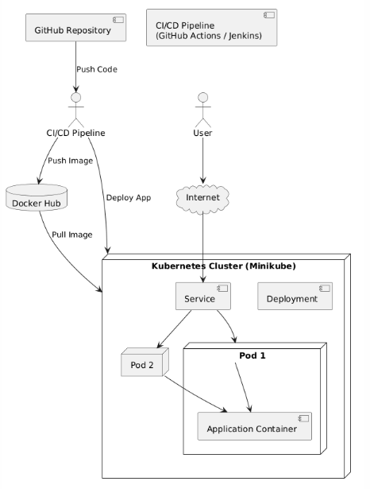
3.2 DATA ACCESS MECHANISM
- GitHub repository access is secured using authentication tokens and SSH keys; only authorized contributors may push code or trigger pipelines.
- Docker Hub image registry access is controlled through Docker login credentials with versioned image tags for traceability.
- Kubernetes cluster resources are managed via kubectl with appropriate Role-Based Access Control (RBAC) policies.

3.3 DATA RETENTION POLICIES
- Pipeline logs are stored for monitoring, debugging, and audit purposes.
- Docker images are versioned with tags in Docker Hub to support rollback to previous application versions.
- Kubernetes deployment history is maintained to allow rollback using kubectl rollout undo.

3.4 DATA MIGRATION
- New application versions create new Docker images tagged with updated version identifiers.
- Kubernetes Rolling Update deploys updated containers on pods incrementally without downtime.
- Older Docker image versions remain available in Docker Hub for rollback if needed.

4. INTERFACES
The system provides multiple interfaces that enable interaction between users and the CI/CD pipeline as well as communication between different system components. These interfaces ensure smooth operation, monitoring, and management of the Insurance Application throughout its deployment lifecycle. The primary interfaces in the system include the user interface and the command-line interface.

4.1 USER INTERFACE
- GitHub interface is used for source code management, pull request review, and pipeline trigger configuration.
- Jenkins/GitHub Actions dashboard is used to monitor pipeline stages, build logs, and deployment status.
- Minikube Dashboard is a web-based Kubernetes UI for monitoring pod status, deployment rollout, and resource usage.
These interfaces provide visibility and control over the system.

4.2 COMMAND LINE INTERFACE
- Git CLI is used for version control operations including staging, committing, and pushing code to GitHub.
- Docker CLI is used for building images, running containers, tagging, and pushing to Docker Hub.
- kubectl CLI is the primary tool for applying manifests, managing deployments, viewing logs, and executing rollbacks.
- Minikube CLI is used to start, stop, and manage the local Kubernetes cluster and expose services.
CLI tools provide flexibility and automation capabilities for developers and engineers.

5. STATE AND SESSION MANAGEMENT
- Kubernetes maintains the desired state of the application as defined in the Deployment manifest; deviations are automatically corrected.
- CI/CD pipeline tracks the state of each stage (build, push, deploy) and reports success or failure.
- Rolling Update state is managed by Kubernetes, which tracks how many pods have been updated while ensuring availability constraints.
- Application sessions are managed within the Insurance Application container independently of the Kubernetes infrastructure.
This ensures system stability, continuous availability, and predictable deployment behavior.

6. CACHING
- Docker layer caching is utilized during image builds; unchanged layers are reused across builds to reduce build times.
- Dependency caching in the CI/CD pipeline stores installed packages between runs, reducing redundant downloads.
- Kubernetes image pull policy is configured as IfNotPresent for stable image tags to avoid re-pulling cached images.
- Pipeline artifacts are reused to optimize multi-stage build performance and overall pipeline efficiency.
Caching improves system speed and performance.

7. FUNCTIONAL REQUIREMENTS
The functional requirements define the core capabilities that the Kubernetes deployment system must provide to ensure automated, reliable, and zero-downtime delivery of the Insurance Application. These requirements describe the expected system behavior and the services it offers to developers and administrators.

7.1 CONTAINERIZATION AND IMAGE BUILD
- The system must package the Insurance Application into a Docker container using a Dockerfile that defines the runtime environment and dependencies.
- The CI/CD pipeline must automatically build a new Docker image whenever new code is pushed to the repository.
- Each Docker image must be tagged with a unique version identifier for traceability and rollback support.

7.2 KUBERNETES DEPLOYMENT
- The system must deploy the containerized Insurance Application onto a Kubernetes cluster (Minikube) using Deployment manifests.
- The Deployment manifest must define the number of pod replicas, image version, resource limits, and update strategy.
- A Kubernetes Service manifest must expose the application to external traffic via a stable endpoint.

7.3 ROLLING UPDATES (ZERO DOWNTIME)
- The system must support zero-downtime deployments through Kubernetes Rolling Update strategy configured in the Deployment manifest.
- Rolling Updates must incrementally replace old pods with new pods while maintaining the minimum required number of available pods.
- The system must support rollback to a previous stable image version using kubectl rollout undo in case a new deployment fails.

7.4 MONITORING AND LOGGING
- The system must provide monitoring of pod status, deployments, and services through kubectl and the Minikube dashboard.
- Application and pod logs must be accessible via kubectl logs for debugging and operational monitoring.
- The CI/CD pipeline must generate detailed logs for each stage accessible to developers and administrators.

8. NON-FUNCTIONAL REQUIREMENTS
The non-functional requirements describe the quality attributes and constraints of the Kubernetes deployment system for the Insurance Application. These requirements ensure that the system performs efficiently, remains secure, and scales effectively while maintaining reliability and usability.

8.1 SECURITY
- All CI/CD pipeline secrets including Docker Hub credentials and Kubernetes configuration are stored as encrypted secrets, never in plain text.
- Kubernetes RBAC (Role-Based Access Control) is enforced to restrict access to cluster resources.
- Docker images follow security best practices with no unnecessary root privileges as specified in the Dockerfile.

8.2 PERFORMANCE
- Fast automated Docker build and deployment process minimizing developer feedback latency.
- Docker layer caching employed to accelerate repeated image builds in the CI/CD pipeline.
- Kubernetes resource limits (CPU and memory) defined to ensure fair resource allocation across pods.

8.3 SCALABILITY
- Kubernetes Deployment configuration allows horizontal scaling of the Insurance Application by adjusting the replica count.
- The architecture supports addition of Horizontal Pod Autoscaler (HPA) in future iterations.
- The system design remains functional across Kubernetes environments from local Minikube to cloud-managed clusters.

8.4 RELIABILITY
- Kubernetes self-healing ensures that failed pods are automatically restarted, maintaining the desired running replicas.
- Rolling Updates guarantee application availability throughout version transitions, eliminating deployment downtime.
- Docker image versioning and Kubernetes rollout history provide a reliable rollback mechanism.

9. REFERENCES
[1] DevOps Course Material, Medicaps University – Datagami Skill Based Course, 2025–2026.
[2] Docker Documentation, “Docker Official Documentation,” [Online]. Available: https://docs.docker.com
[3] Kubernetes Documentation, “Kubernetes Official Documentation,” [Online]. Available: https://kubernetes.io/docs
[4] Minikube Documentation, “Minikube Official Documentation,” [Online]. Available: https://minikube.sigs.k8s.io/docs
[5] GitHub Documentation, “GitHub Official Documentation,” [Online]. Available: https://docs.github.com
[6] Jenkins Documentation, “Jenkins User Documentation,” [Online]. Available: https://www.jenkins.io/doc
[7] GitHub Actions Documentation, “GitHub Actions Documentation,” [Online]. Available: https://docs.github.com/actions
[8] Insurance App Project Repository, GitHub, 2026. Available: https://github.com/avanisharma-5/Deploy_Insurance_App

10. GITHUB
https://github.com/avanisharma-5/Deploy_Insurance_App

